WEEK 7
REACTJS
EXERCISE 9: Create a React Application named “cricketapp” with the following components:
IndianPlayers.js
// src/Components/IndianPlayers.js
import React from 'react';

const IndianPlayers = () => {
const players = [
{ name: "Virat" },
{ name: "Rohit" },
{ name: "Dhoni" },
{ name: "Raina" },
{ name: "Kohli" },
{ name: "Pant" },
{ name: "Hardik" },
{ name: "Rahul" },
{ name: "Shikhar" },
{ name: "Ashwin" },
{ name: "Jadeja" },
];

const oddPlayers = players.filter((_, index) => index % 2 !== 0);
const evenPlayers = players.filter((_, index) => index % 2 === 0);

const T20Players = ["Virat", "Rohit", "Pant"];
const RanjiPlayers = ["Jadeja", "Ashwin", "Rahane"];
const mergedPlayers = [...T20Players, ...RanjiPlayers];

return (
<div>
<h2>Odd Index Players</h2>
<ul>
{oddPlayers.map((player, index) => (
<li key={index}>{player.name}</li>
))}
</ul>

<h2>Even Index Players</h2>
<ul>
{evenPlayers.map((player, index) => (
<li key={index}>{player.name}</li>
))}
</ul>

<h3>Merged Players (T20 + Ranji)</h3>
<ul>
{mergedPlayers.map((player, index) => (
<li key={index}>{player}</li>
))}
</ul>
</div>
);
};

export default IndianPlayers;

ListofPlayers.js
// src/Components/ListofPlayers.js
import React from 'react';

const ListofPlayers = () => {
const players = [
{ name: "Virat", score: 80 },
{ name: "Rohit", score: 90 },
{ name: "Dhoni", score: 50 },
{ name: "Raina", score: 45 },
{ name: "Kohli", score: 76 },
{ name: "Pant", score: 30 },
{ name: "Hardik", score: 55 },
{ name: "Rahul", score: 85 },
{ name: "Shikhar", score: 67 },
{ name: "Ashwin", score: 72 },
{ name: "Jadeja", score: 92 },
];

const lowScorers = players.filter(player => player.score < 70);

return (
<div>
<h2>All Indian Players</h2>
<ul>
{players.map((player, index) => (
<li key={index}>{player.name} - {player.score}</li>
))}
</ul>

<h3>Players with Score Less Than 70</h3>
<ul>
{lowScorers.map((player, index) => (
<li key={index}>{player.name} - {player.score}</li>
))}
</ul>
</div>
);
};

export default ListofPlayers;

App.js
// src/App.js
import React from 'react';
import ListofPlayers from './Components/ListofPlayers';
import IndianPlayers from './Components/IndianPlayers';

function App() {
const flag = true; // Change to false to test the other view

return (
<div className="App">
<h1> Cricket App</h1>
{flag ? <ListofPlayers /> : <IndianPlayers />}
</div>
);
}

export default App;

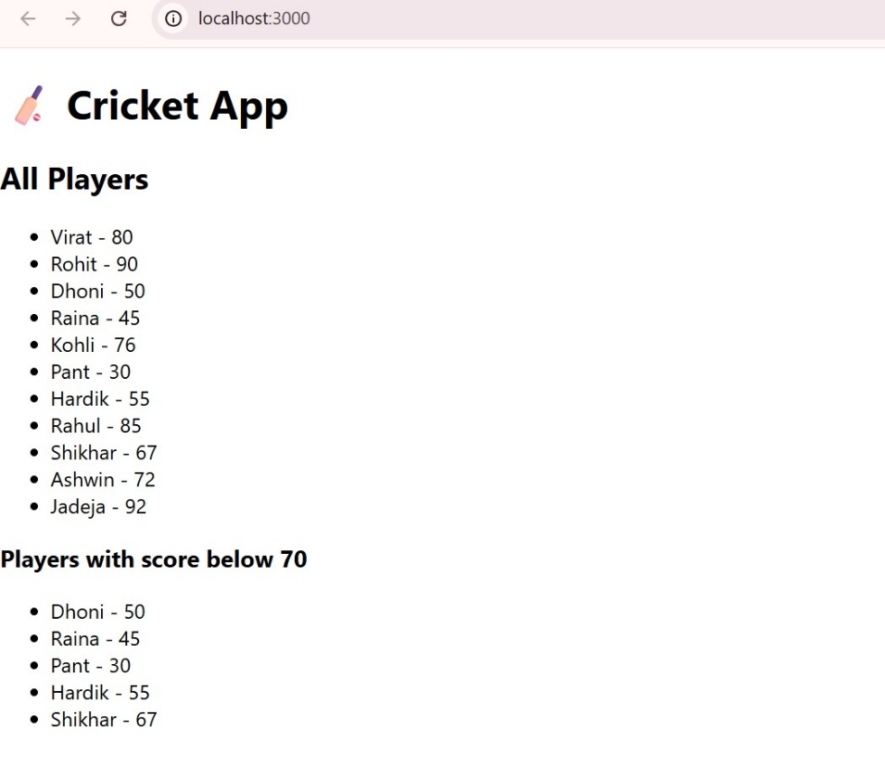
const flag = false;
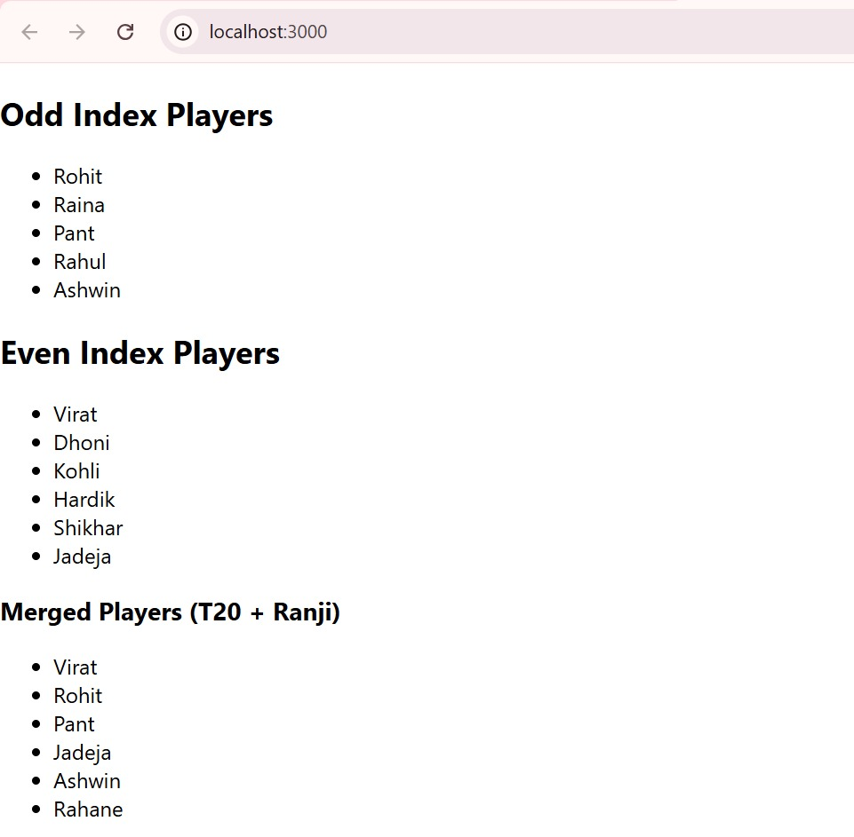
EXERCISE 10: Create a React Application named “officespacerentalapp” which uses React JSX to create elements, attributes and renders DOM to display the page.
OfficeSpaceList.js
// src/Components/OfficeSpaceList.js
import React from 'react';
import './OfficeSpaceList.css';

const OfficeSpaceList = () => {
// List of office objects
const officeList = [
{
id: 1,
name: "Elite Co-working Space",
rent: 55000,
address: "Tidel Park, Chennai",
image: "https://via.placeholder.com/200?text=Elite+Office"
},
{
id: 2,
name: "Prime Office Hub",
rent: 72000,
address: "HSR Layout, Bangalore",
image: "https://via.placeholder.com/200?text=Prime+Hub"
},
{
id: 3,
name: "Startup Hive",
rent: 48000,
address: "Tech City, Hyderabad",
image: "https://via.placeholder.com/200?text=Startup+Hive"
},
];

return (
<div>
<h1>🏢 Office Space Rental App</h1>

{officeList.map((office) => (
<div key={office.id} className="office-card">
<img src={office.image} alt={office.name} />
<h3>{office.name}</h3>
<p className={office.rent < 60000 ? 'low-rent' : 'high-rent'}>
Rent: ₹{office.rent}
</p>
<p>Address: {office.address}</p>
</div>
))}
</div>
);
};

export default OfficeSpaceList;

OfficeSpaceList.css
/* src/Components/OfficeSpaceList.css */

.office-card {
border: 1px solid #ccc;
padding: 16px;
margin: 12px;
width: 250px;
display: inline-block;
text-align: center;
box-shadow: 2px 2px 5px rgba(0,0,0,0.1);
}

.low-rent {
color: red;
font-weight: bold;
}

.high-rent {
color: green;
font-weight: bold;
}

img {
width: 200px;
height: 150px;
object-fit: cover;
}

App.js
// src/App.js
import React from 'react';
import OfficeSpaceList from './Components/OfficeSpaceList';

function App() {
return (
<div className="App">
<OfficeSpaceList />
</div>
);
}

export default App;

Output:
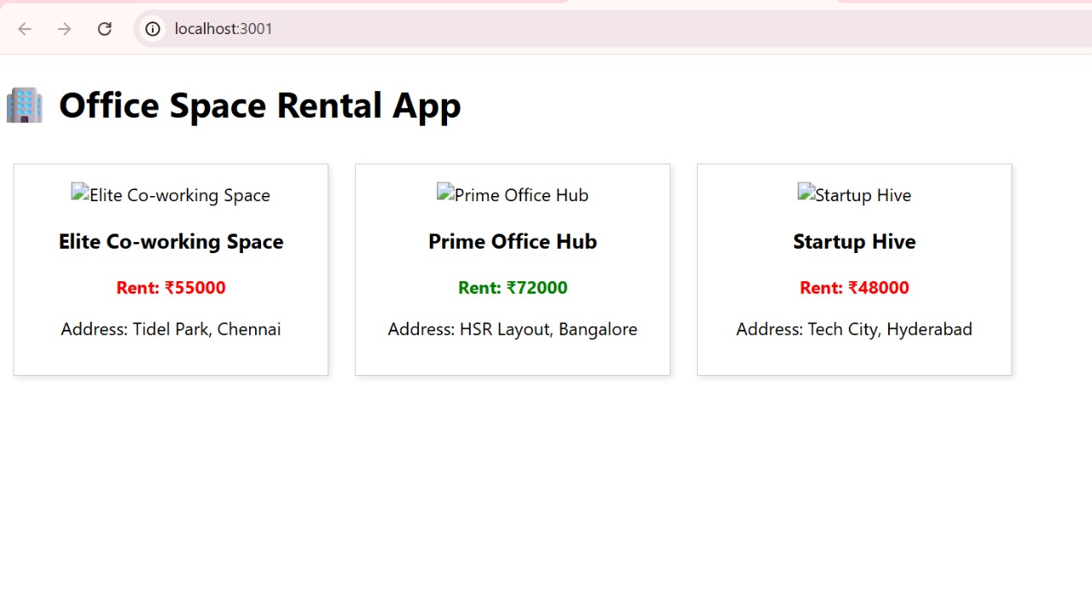
Assignment – 11
Creating the react app
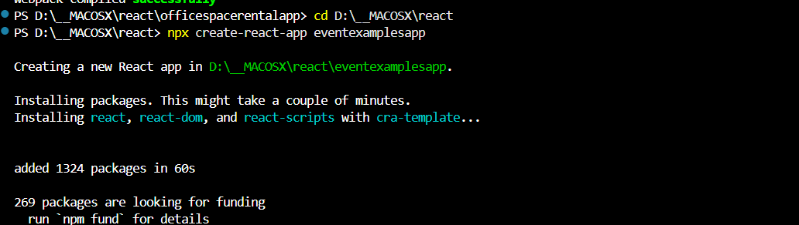

Working Directory :

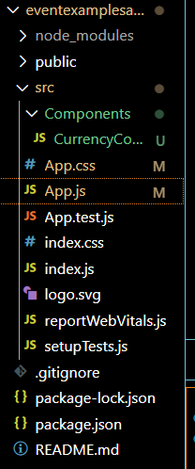

APP.JS CODE
import React, { useState } from 'react';
import './App.css';
import CurrencyConverter from './Components/CurrencyConverter';

function App() {
const [count, setCount] = useState(0);

const increment = () => {
setCount(prev => prev + 1);
sayHello();
showMessage();
};

const decrement = () => {
setCount(prev => prev - 1);
};

const sayHello = () => {
console.log("Hello!");
};

const showMessage = () => {
console.log("This is a static message after Hello.");
};

const sayWelcome = (message) => {
alert(message);
};

const onPressHandler = () => {
alert("I was clicked");
};

return (
<div className="App">
<h1>Event Examples App</h1>

<div className="counter-section">
<h2>Counter: {count}</h2>
<button onClick={increment}>Increment</button>
<button onClick={decrement}>Decrement</button>
</div>

<div className="button-section">
<button onClick={() => sayWelcome("Welcome!")}>Say Welcome</button>
<button onClick={onPressHandler}>Click on me</button>
</div>
<CurrencyConverter />
</div>
);
}

export default App;

APP.CSS CODE :
.App {
text-align: center;
padding: 2rem;
font-family: Arial, sans-serif;
}

.counter-section,
.button-section,
.currency-converter {
margin-bottom: 2rem;
}

button {
margin: 5px;
padding: 8px 12px;
}

input {
margin-left: 10px;
padding: 5px;
}

h2 {
color: green;
}

COMPONENTS/CURRENCYCONVERTER.JS CODE

import React, { useState } from 'react';

function CurrencyConverter() {
const [rupees, setRupees] = useState('');
const [euros, setEuros] = useState(null);
const conversionRate = 0.011;

const handleSubmit = (e) => {
e.preventDefault();
const converted = parseFloat(rupees) * conversionRate;
setEuros(converted.toFixed(2));
};

return (
<div className="currency-converter">
<h2 style={{ color: 'green' }}>Currency Convertor!!!</h2>
<form onSubmit={handleSubmit}>
<label>Amount (INR): </label>
<input
type="number"
value={rupees}
onChange={(e) => setRupees(e.target.value)}
placeholder="Enter INR"
/>
<br /><br />
<button type="submit">Submit</button>
</form>
{euros !== null && (
<p><strong>{rupees} INR = {euros} EUR</strong></p>
)}
</div>
);
}

export default CurrencyConverter;
OUTPUT :

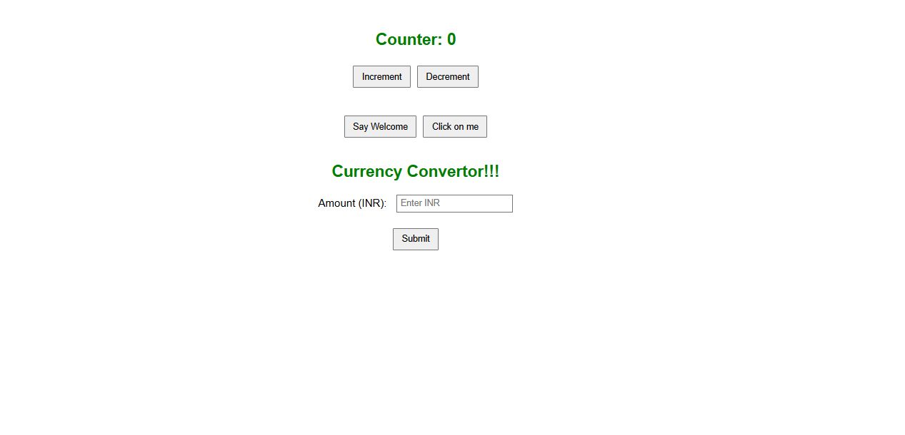

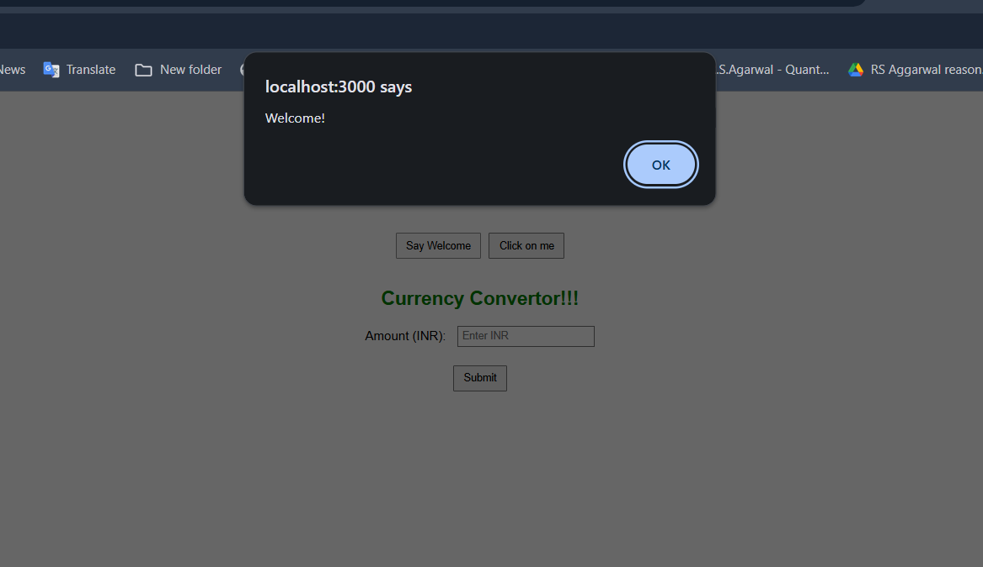
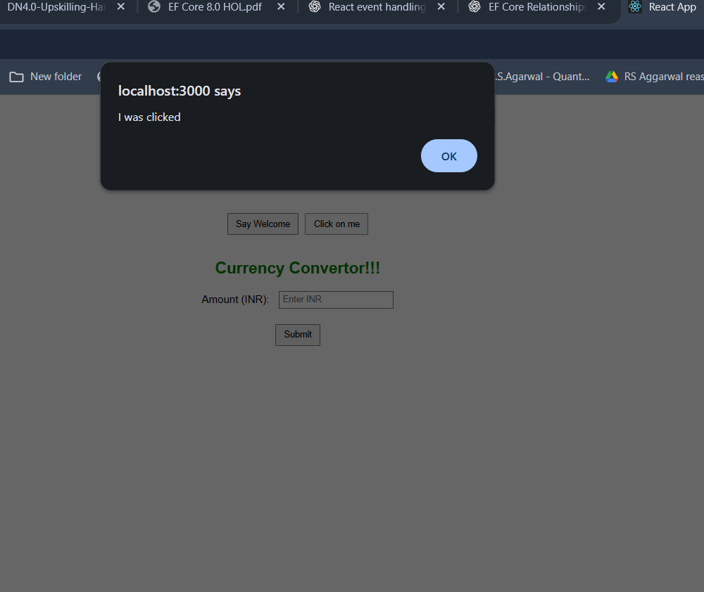
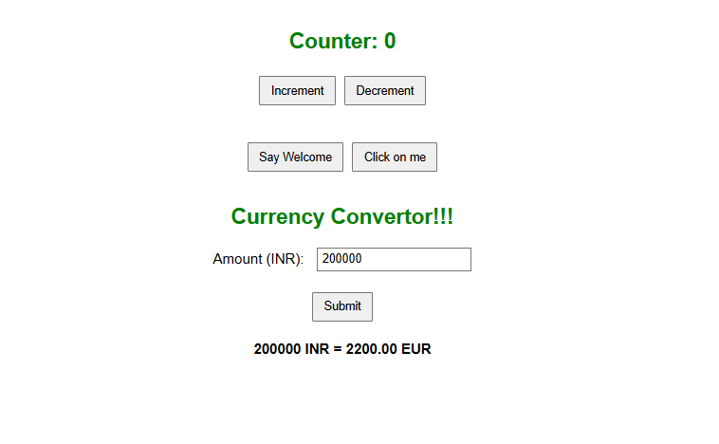

Counter Incremented to 6 using button
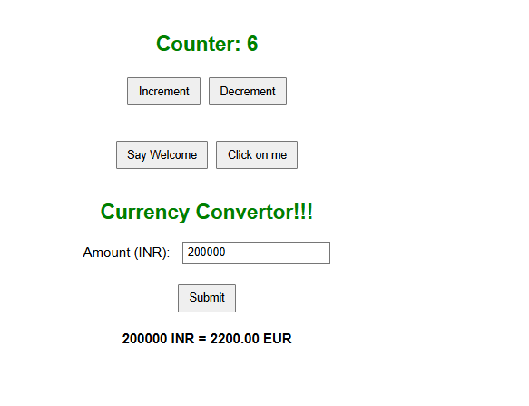
Counter decrement to 4 using decrement button :
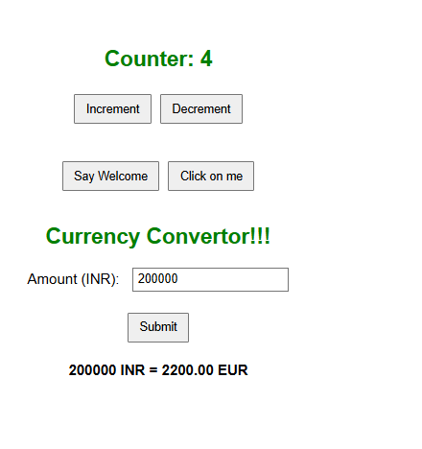

ASSIGNMENT 12
Creating the react app for ticket booking
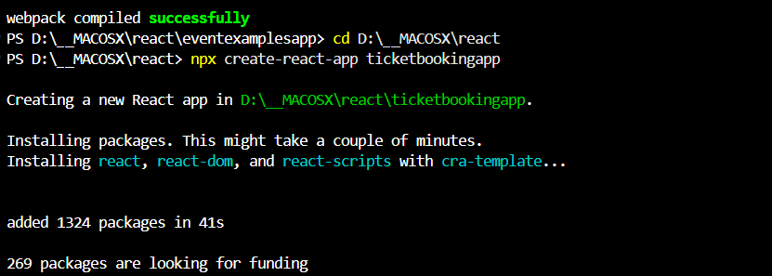
Working Directory :
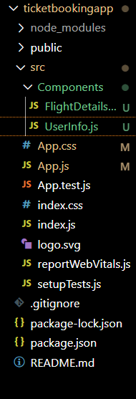

APP.JS CODE :
import React, { useState } from 'react';
import './App.css';
import FlightDetailsPage from './Components/FlightDetailsPage';
import UserInfo from './Components/UserInfo';

function App() {
const [isLoggedIn, setIsLoggedIn] = useState(false);

const user = {
name: 'Barath S.',
email: 'barath@example.com',
};

const handleLogin = () => setIsLoggedIn(true);
const handleLogout = () => setIsLoggedIn(false);

return (
<div className="App">
<h1>Ticket Booking App</h1>

{isLoggedIn ? (
<>
<button onClick={handleLogout}>Logout</button>
<UserInfo user={user} />
<FlightDetailsPage />
</>
) : (
<>
<button onClick={handleLogin}>Login</button>
<p>Please log in to view available flights.</p>
</>
)}
</div>
);
}

export default App;

APP.CSS CODE
.App {
text-align: center;
padding: 2rem;
font-family: Arial, sans-serif;
}

button {
padding: 10px 15px;
margin: 10px;
font-size: 16px;
cursor: pointer;
}

table {
margin: 20px auto;
border-collapse: collapse;
width: 80%;
}
th, td {
padding: 10px;
border: 1px solid #ddd;
}

.user-info {
margin: 20px;
text-align: left;
display: inline-block;
}

CREATE COMPONENTS FOLDER :
FLIGHTDETAILS.JS
import React from 'react';

const flights = [
{ id: 1, airline: 'IndiGo', from: 'Chennai', to: 'Delhi', time: '10:00 AM', price: '₹4500' },
{ id: 2, airline: 'Air India', from: 'Mumbai', to: 'Bangalore', time: '1:30 PM', price: '₹5200' },
{ id: 3, airline: 'SpiceJet', from: 'Hyderabad', to: 'Kolkata', time: '6:45 PM', price: '₹4800' },
{ id: 4, airline: 'Emirates', from: 'Hyderabad', to: 'Joneshburg', time: '6:45 PM', price: '₹430000' },
{ id: 7, airline: 'Luftansa', from: 'Hyderabad', to: 'London,Oval', time: '6:45 PM', price: '₹400000' },
];

function FlightDetailsPage() {
return (
<div className="flight-details">
<h2>Available Flights</h2>
<table border="1" cellPadding="10">
<thead>
<tr>
<th>ID</th>
<th>Airline</th>
<th>From</th>
<th>To</th>
<th>Time</th>
<th>Price</th>
</tr>
</thead>
<tbody>
{flights.map((flight) => (
<tr key={flight.id}>
<td>{flight.id}</td>
<td>{flight.airline}</td>
<td>{flight.from}</td>
<td>{flight.to}</td>
<td>{flight.time}</td>
<td>{flight.price}</td>
</tr>
))}
</tbody>
</table>
</div>
);
}

export default FlightDetailsPage;

USERINFO.JS
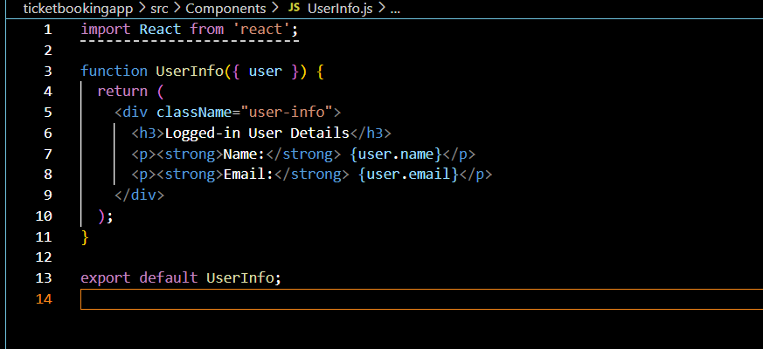
OUTPUT :
Guest Page :
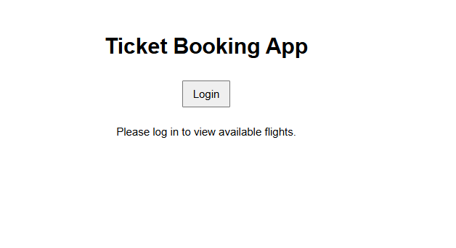
User Login Page :
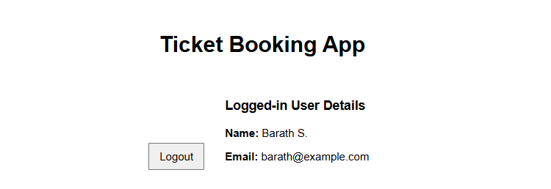
Flight details display in customer page :
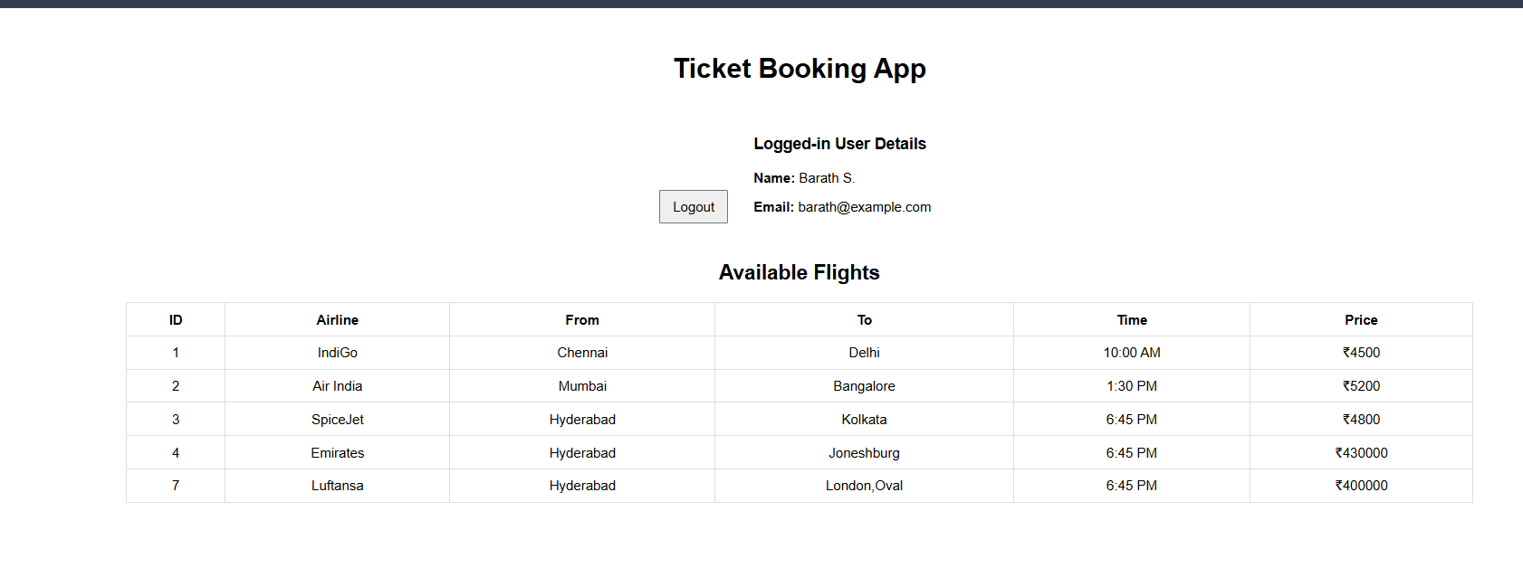
ASSIGNMENT – 13
Creating the react app
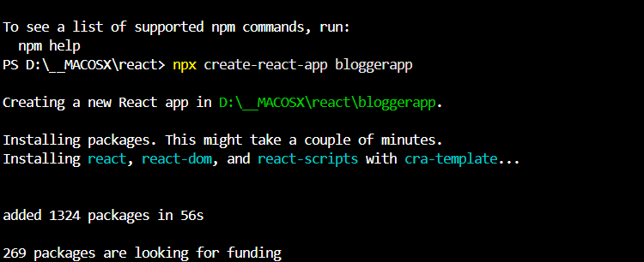

Working directory :
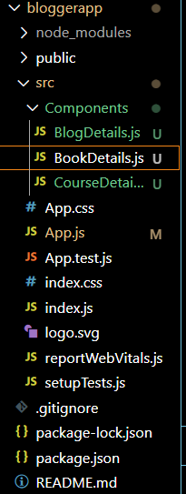
APP.JS CODE :
import React from 'react';
import './App.css';

function App() {
const bookdet = (
<ul>
{books.map(book => (
<li key={book.id}>
<strong>{book.bname}</strong> - ₹{book.price}
</li>
))}
</ul>
);

const content = (
<div>
<p>Welcome to our programming blog! Here you'll find tutorials on React, Angular, and MongoDB.</p>
<p>New articles are posted every week covering the latest web development technologies.</p>
</div>
);

const coursedet = (
<ul>
{courses.map(course => (
<li key={course.id}>
<strong>{course.cname}</strong> - {course.duration} hours ({course.level})
</li>
))}
</ul>
);

return (
<div className="container">
<div className="st2">
<h1>Book Details</h1>
{bookdet}
</div>
<div className="v1">
<h1>Blog Details</h1>
{content}
</div>
<div className="mystyle1">
<h1>Course Details</h1>
{coursedet}
</div>
</div>
);
}

export const books = [
{id: 101, bname: 'Master React', price: 670},
{id: 102, bname: 'Deep Dive into Angular 11', price: 800},
{id: 103, bname: 'Mongo Essentials', price: 450},
{id: 104, bname: 'JavaScript: The Good Parts', price: 550},
{id: 105, bname: 'Clean Code', price: 720},
{id: 106, bname: 'Design Patterns', price: 890},
{id: 107, bname: 'TypeScript Handbook', price: 620},
{id: 108, bname: 'Node.js in Action', price: 780},
{id: 109, bname: 'Python Crash Course', price: 590},
{id: 110, bname: 'Data Structures and Algorithms', price: 950}
];

export const courses = [
{id: 201, cname: 'React Fundamentals', duration: 15, level: 'Beginner'},
{id: 202, cname: 'Advanced Angular', duration: 20, level: 'Intermediate'},
{id: 203, cname: 'MongoDB for Developers', duration: 10, level: 'Beginner'},
{id: 204, cname: 'Full Stack Development', duration: 30, level: 'Advanced'}
];

export default App;

APP.CSS

.container {
display: flex;
flex-wrap: wrap;
gap: 20px;
padding: 20px;
font-family: Arial, sans-serif;
}

.st2, .v1, .mystyle1 {
flex: 1;
min-width: 300px;
padding: 20px;
border-radius: 8px;
box-shadow: 0 2px 5px rgba(0,0,0,0.1);
}

.st2 {
background-color: #f0f8ff;
}

.v1 {
background-color: #fff0f5;
}

.mystyle1 {
background-color: #f0fff0;
}

h1 {
color: #333;
border-bottom: 2px solid #666;
padding-bottom: 10px;
}

ul {
list-style-type: none;
padding: 0;
}

li {
padding: 8px 0;
border-bottom: 1px solid #eee;
}

strong {
color: #2c3e50;
}

OUTPUT :

